BARCODE AND QR CODE SCANNER APP

INTRODUCTION

**Brief Description:**

Barcode and QR code scanner app is a technique which allows us to scan the barcode or QR code given at the back of a product and displays a link which can be visited when clicked to get the information about the product provided by the company. Every product has its own code which is used for providing information about it. Even different types of cards has codes at their back.

The scanner should have a light source, lens and light sensor translating for optical impulses into electrical signals. All these are present in a mobile, so we create an app to start scanning the codes rather than buying a flatbed scanner which is not considered as a good idea for an individual use rather it can be used for an organization.

**Problem Statement:**

In this project we have created an app for scanning barcode and QR codes which is used to give information about the product being used.

The problem of scanning the codes using the hand held scanners is resolved without buying it. Customers only need to install the application in their android phone to read those codes.

**Objective:**

The first and foremost objective of this project is to scan and download the codes printed at the back of any product within seconds without buying the hand held scanners which increases the extra expenses of a person. This application helps in reducing such costs and makes a handy scanner available to each person who uses mobile.

EXISTING SYSTEM

There are a large number of applications available on google play with the name of QR and Barcode Scanner, or just QR code Scanner or Barcode Scanner. There are app which also generate QR codes and Barcodes which can be assigned to any product.

There are some applications which also store the scan history, this helps it to be used later when the product is not available.

PROPOSED WORK

**Software used to develop the project:**

Android Studio

Android Studio is the official integrated development environment for Google’s Android OS, built on JetBrains’ IntelliJ IDEA software and designed specifically for Android development.

SQLite

SQLite is a C- language library that implements a small, fast, self- contained, high- reliable, full- featured, SQL database engine. It is the most used database engine in the world. It can be built into all mobile phones and all PCs and is used in numerous other applications which we use everyday.

**Programming language used**

Java- Java is the official and most preferred language for Android development and is fully and perfectly supported by Android Studio software. It is the most supported language by Google and most of the apps in play store are built on this language. It was developed by Sun Microsystems. It is one of the most popular object- oriented programming languages and can be easily understood.

**Description of each module-**

1. The very first page of the app. Which just displays a picture of a random code stating about the scanner app. It is displayed for 5 seconds when opened. Then goes to the second module.
2. The second module of the app displays a text written hello world and two buttons, scan code and display respectively.
3. Third module accesses the camera of the device and starts scanning the QR code or Barcode.
4. Last module displays the result by giving the link obtained after the scanning process.

**UI design of each module-**

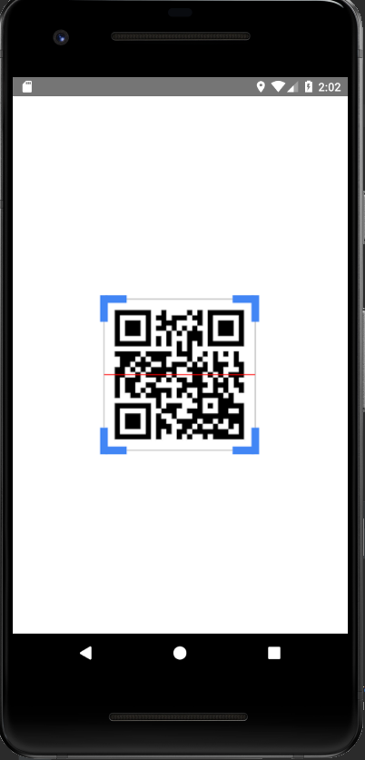

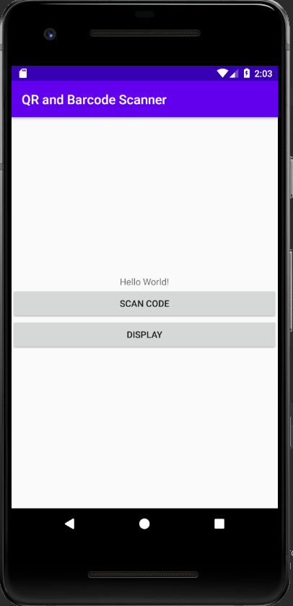

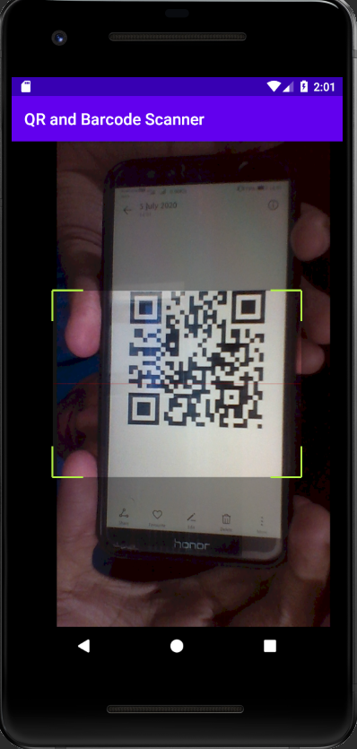 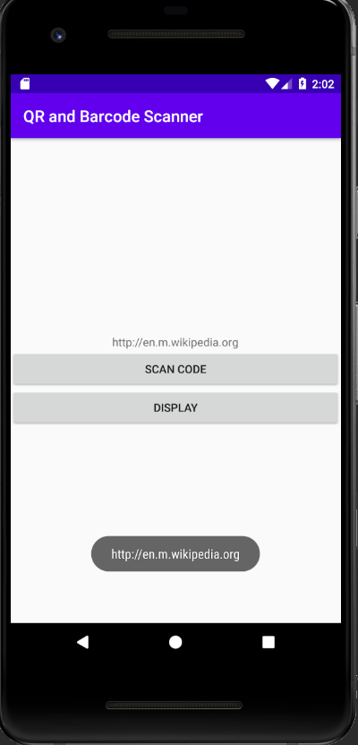

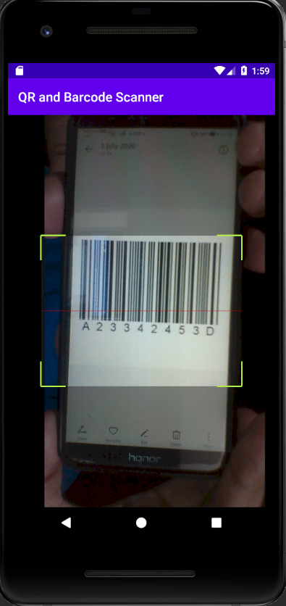 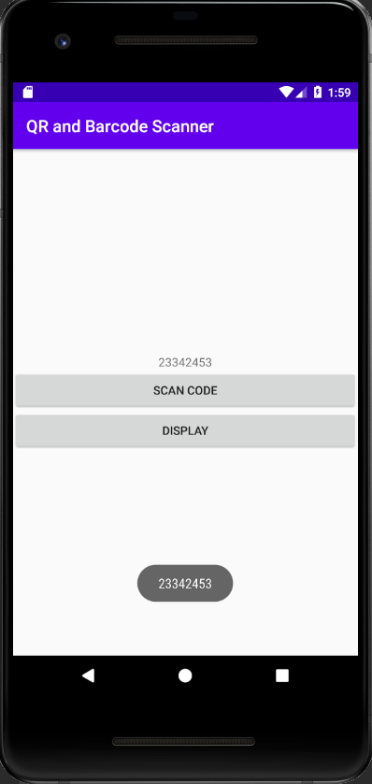

**Database design and databases will be used-**

Database will be designed later. This database will store the scan history of the app so that it can be used later when required and when the product is not available for scanning. The website links obtained after scanning can be visited later easily. We are going to use SQLite to build the database in this application.

**Features of the project:**

* Camera Access

Camera permission is a mandatory one in this application as it needs to use the camera to scan the code.

* Storage Access

Storage permission is not mandatory one but if the user of the application needs to store the history of the scans then he has to give storage access to the app.

* Media Access

Media Access is also required when the person needs to scan up the screenshots stored in the gallery.

PROJECT TEAM MEMBERS:

* BHAVYA (1760436)
* NIKHIL G. ALEX (1760478)

ROLES AND RESPONSIBILITIES of individual team members:

* Bhavya- Handling the report part and explanation of the codes used in this application.
* Nikhil G. Alex- Designing UI and implementing the codes of the project in android studio software.